Equality Review Form |  |  |  |  | 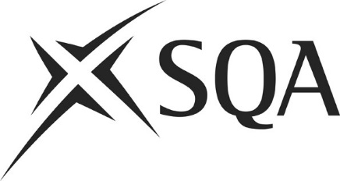
Unit title and SCQF level
SQA Lead Officer
Part A
Please consider each of the protected characteristics below and identify those learners with different protected characteristics who may be adversely affected by a part or requirement of the Course.
Disability |  |  |  | Gender Reassignment
Pregnancy & Maternity |  |  |  | Race
Religion or Belief |  |  |  | Sex
Sexual Orientation |  |  |  | Age
Please record here your consideration of the potential barriers you have identified for learners on grounds of any of the protected characteristics ticked above and any action you have taken during the development to remove/mitigate these barriers.

Part B (for disability only)
If the adverse impact is related to a learner’s disability, then you must consider if there are any assessment arrangements/reasonable adjustments that could be made to remove or mitigate the adverse impact. Record your considerations here.
Are there any standard assessment arrangements which could be put in place to remove the adverse impact for disabled learners?

Are there any alternative forms of evidence (of a comparable standard) for disabled learners that you are aware of which will generate the necessary evidence of achievement?

Are there any potential barriers to any of the protected characteristics which cannot be removed and therefore should be considered by QDMT?
Date Equality Review Form completed
Part C
To be completed by the QM after QDMT discussion.
Where QDMT have decided not to progress to Stage 2 – the QM should note the decision made here and the reasoning.

Part D: Stage 2 and 3
To be completed if QDMT has agreed to an issue being escalated to Stage 2
Record here a summary of the equality issue and recommendations for QC.

Ensure that at each of the following stages, all appropriate papers/minutes/action notes are attached.
Equality issue paper presented to QDMT |  |  | Date
Escalation of equality issue to Stage 2 agreed by QDMT |  |  | Date
Consultation plan agreed by QDMT |  |  | Date
Further equality issue paper submitted to QDMT |  |  | Date
Recommendations submitted to Qualifications Committee |  |  | Date
Communication plan agreed by QDMT |  |  | Date

Completed forms should be e-mailed to annette.foulcer@sqa.org.uk

If the adverse impact is related to a learner’s disability, you must complete Part B

